CREATIVE EDUCATIONAL SERVICES
END OF TERM THREE EXAMINATION-2024
PRIMARY ONE

READING.

TIME ALLOWED: 2 HOURS 15 MINUTES.

Name ________________________________________________ Stream _____________
SCHOOL___________________ ______________________________________________

DO NOT OPEN THIS BOOKLET UNTIL YOU ARE TOLD TO DO SO.
Read the following instructions carefully.

- Read the questions carefully before answering any question.
- Answer all questions in the space provided.

- Write well. Unnecessary crossing of work will lead to loss of marks.

- Wrong spellings will lead to loss of marks.

- Any handwriting that cannot be read may lead to loss of marks.

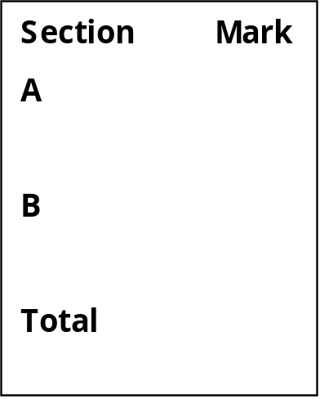

SECTION A : (40 MARKS)

1. Copy them correctly.

_____________________________________________________________
_____________________________________________________________
_____________________________________________________________
Paul Peter Pamela
_____________________________________________________________
_____________________________________________________________
Patience pushed Peter in the parking.
_____________________________________________________________
_____________________________________________________________
3. Fill in the missing letters.
(a) c __r (b) r__ pe
(c) b__cycle (d) sk___pping
4. Listen and write.
(a) ________________________ (b) ____________________________
(c) ________________________________________________________

5. Make words using the given sounds.
th

sm
ell
all
ile

art

6. Write these words correctly.
(a) rtain ________________ (c) therfa __________________
(b) atm _________________ (d) dora __________________
7. Write a sentence using the word given.
(a) riding ______________________________________________
(b) carpenter _________________________________________
8. Draw these pictures.
aeroplane | basket
9. Write the sentences correctly.
(a) shinning The sun is.
_____________________________________________________

(b) is water Peter drinking.
______________________________________________________
(c) can He play drum big a
______________________________________________________
10. Arrange the sentences to form a good story.
(a) She calls me when it is ready.
(b) I eat my food.
(c) Mummy cooks the food.
(d) I come quickly and wash my hands.
(a) ________________________________________________________
(b) ________________________________________________________
(c) ________________________________________________________
(d) _______________________________________________________
11. Name the pictures.
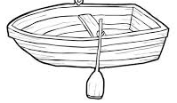 | 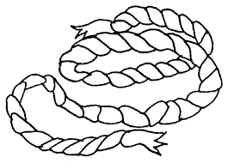

12. Fill in the gaps correctly using the given words below.
bad, late, pencil , teacher, looked

Francis did not wake up in time and was _____________for school. He lost his ___________at home. He did not do his homework and the ______________ was angry with him.
In the classroom, he ______________out of the window instead of paying attention to the teacher. The teacher told him he was a _________________ pupil.

13. Read and complete the riddle below.
(a) I am a man or woman. My work is to fly aeroplanes all
over the world. Who am I? You are a _________________.

(b) I am made of clay. People use me to fetch water and
cook food. What am I? You are a ________________.

14. Study the pictures below and match the actor to the
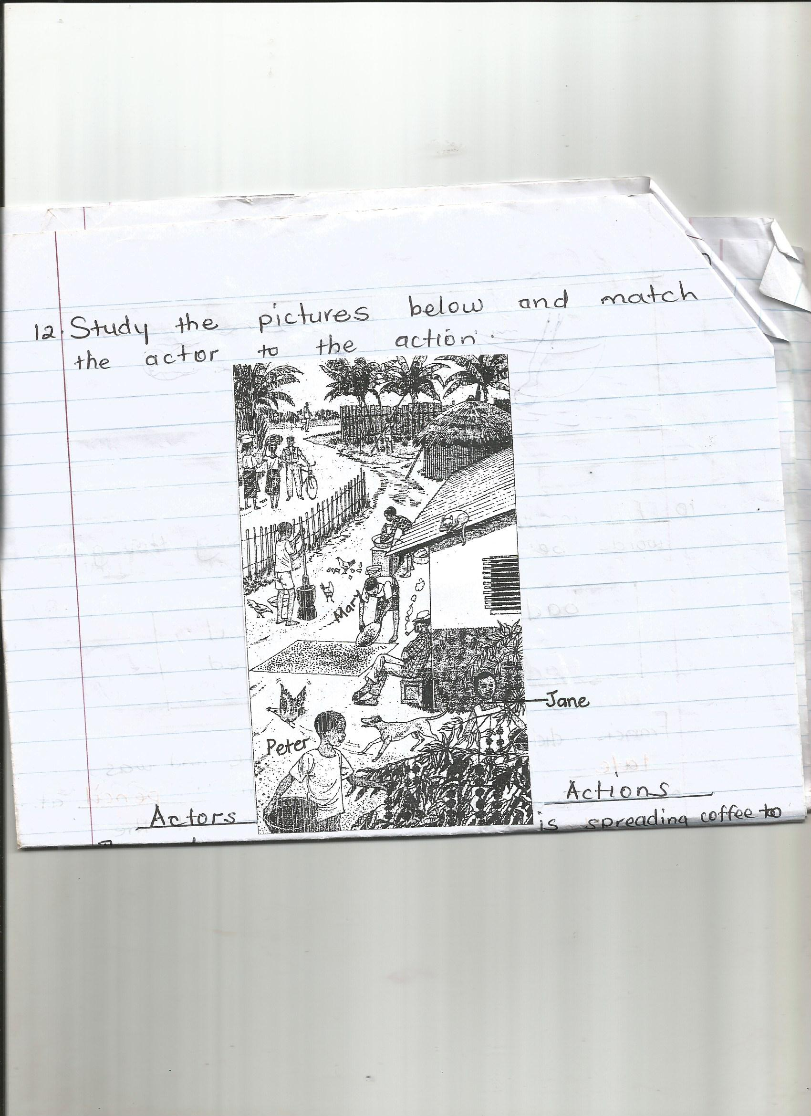
action.

Jane

Actors Actions.
- The dog is spreading coffee to dry.
- The policeman are going to the market.
- The two women on the road is chasing a hen
- Mary are picking coffee.
- Peter and Jane is leaning against a
bicycle.
- The dog __________________________________
- The policeman ___________________________________
- The two women on the road ____________________________
- Mary __________________________________
- Peter and Jane ___________________________________

15. Read the story and answer the questions in full sentences.
Pamela has a little brother who goes to school with her. His name is Tim. He wears a red shirt and a black short. Tim is seven years old. He likes reading stories and watching videos, but he does not like doing homework. This makes his mother very angry. She says she will not buy story books any more.

Questions.
- What does Pamela’s little brother wear?
_________________________________________________________
- What does Pamela’s brother like?
_________________________________________________________
- How old is he?
_________________________________________________________

END.

